**GENERAL ENDORSEMENT (T-3)**

**ISSUED BY**

**WFG National Title Insurance Company**

File No:

Attached to and made a part of WFG National Title Insurance Company Policy No.__________, this ______ day of ________, 20_______.

Nothing herein contained shall be construed as extending or changing the effective date of the aforesaid policy or interim construction binder, unless otherwise expressly stated.

IN WITNESS HEREOF, the WFG NATIONAL TITLE INSURANCE COMPANY has caused this Endorsement to be executed by its President under the seal of the Company, but this Endorsement is to be valid only when it bears an authorized countersignature.

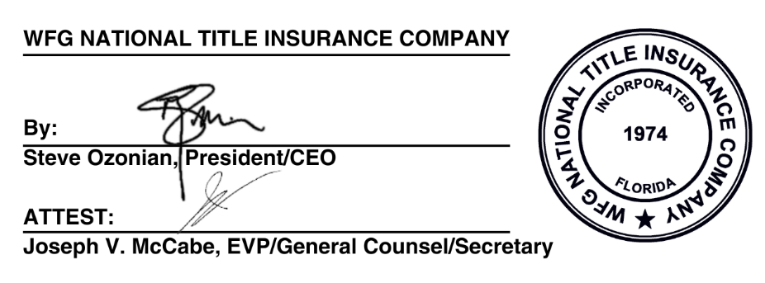

Agent Name:

By: ____________________________________________